**Your Online Database Architecture for Education (YODAE)**

By illustrating the connections between important entities including teachers, students, classrooms, schools, IoT devices, and school personnel, the ERD satisfies the needs of YODAE and its clients. The attributes of each entity are described, guaranteeing that the database system can manage and store the essential data. For instance, information on teachers, including name, email address, and department, is recorded, as well as specifics about the classroom, including grade level and class name.

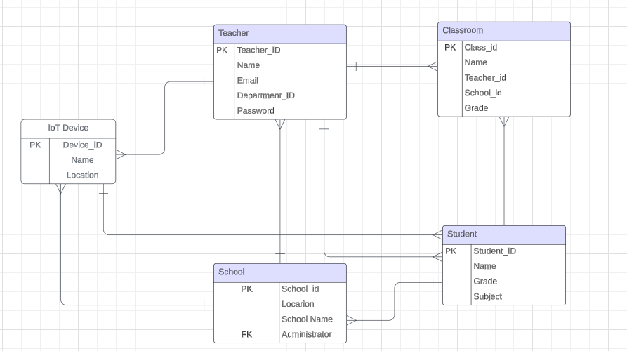

Teacher - Classroom (One-to-Many): A single teacher is in charge of each classroom; however they are all managed by the same person.

Student-Classroom (One-to-Many): It is possible for a classroom to include more than one student, but each student is only associated with one classroom.

Teacher-School (Many-to-One): Each teacher is a member of only one school, but numerous teachers are employed by the same institution.

Classroom-School (Many-to-One): Each classroom is a component of a single school, while the school has many classrooms.

Device - School (Many-to-One): A single school has many installed IoT devices, yet each device is unique to that school.

The relationships between these entities are accurately represented in the ERD, mirroring the real-world situations that are detailed in the business case. For example, the many-to-one link between classrooms and schools denotes that numerous classrooms are a part of one school, whereas the one-to-many relationship between teachers and classrooms highlights the reality that one teacher can oversee multiple classrooms.

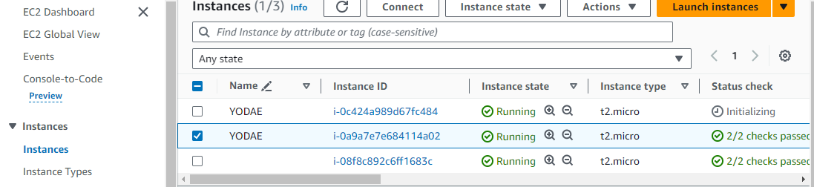

The EC2 Instance Running

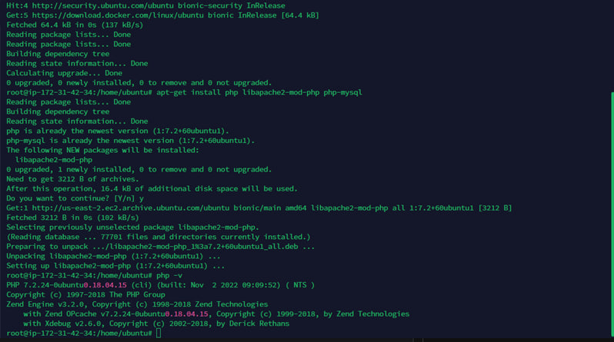

Installing PHP on the instance

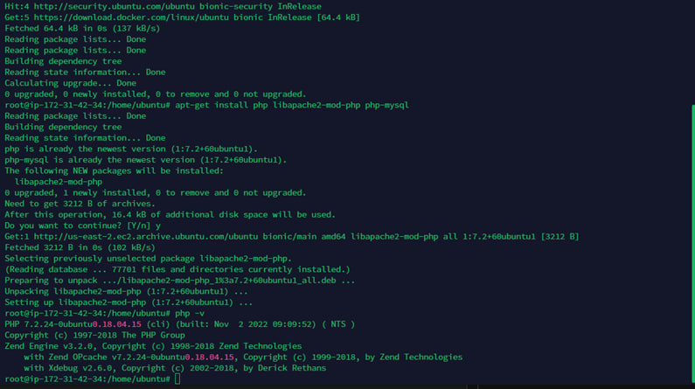

**Showing PHP extensions installed successfully on the EC2 instance**

**MySQL: This is to show that MySQL-Server was successfully installed and we’re now at the Database on AWS server.**

WordPress successfully created

Database configured

**Error even when port 80 IPv4 and IPv6 configured**

**WordPress: This to show that I was successfully WordPress on my server.**

**Logging to the WordPress site successfully**

**Entity Relationship Diagram (ERD): This screenshot below is to show that phpMyAdmin has successfully been connected to ERD Database diagram.**

**Tables:**

**The student’s table was successfully created.**

**View Students Page: This is to show that the View Students page was successfully added**

**Site is live and accessible but, the last step has given me an error. The below screenshot is the site. The function are showing above of the screen which was inserted from the previous step.**

**XYZ PHP Code Plug-in: Error code above is resolved after modified to code to:**

**$students = $wpdb->get_results("SELECT * FROM students;");**

**Add student**